Formal Language and Automata Report

Name: Abhishek Toppo
Class: III-Year AIML 'A'
Roll: RA2411026050048

10th November, 2026

TASK 2:
Designing Automata for Real-time applications Password Verification System, Email Format Validator, ATM PIN Verification etc)

As, an example a capped counter, a fixed set of flags, or the last character class, when a finite automaton is enough: the rule is needing only bounded memory, in real-world scenarios.
Wcw), checking two inputs (password ≠ username), or external state (database, try counter, DNS), when it isn't: the rule is needing unbounded counting or matching (nested brackets, on the whole.

Syntax validation (FA is normally enough) | Semantic / business rules (is needing more than FA)
PIN has exactly 4 digits | PIN matches the one stored for the card; the card isn't blocked
≥8 chars and 4-character classes are had by password | Password isn't leaked, not equal to the username, not reused
Email looks like local@domain.tld | The area exists (DNS) and the mailbox is currently reachable

Alphabet: Σ = {0,1,…,9} ∪ {other}. Language: L₁ = { w ∈ Σ* : |w| = 4 and every symbol is a digit } = D⁴, with regular expression [0-9]{4}, broadly speaking. "other" stands for any non-digit character.
D means any digit. DFA M₁ = (Q, Σ, δ, q0, F), with Q = {q0,q1,q2,q3,q4,φ}, F = {q4}, to a significant degree.

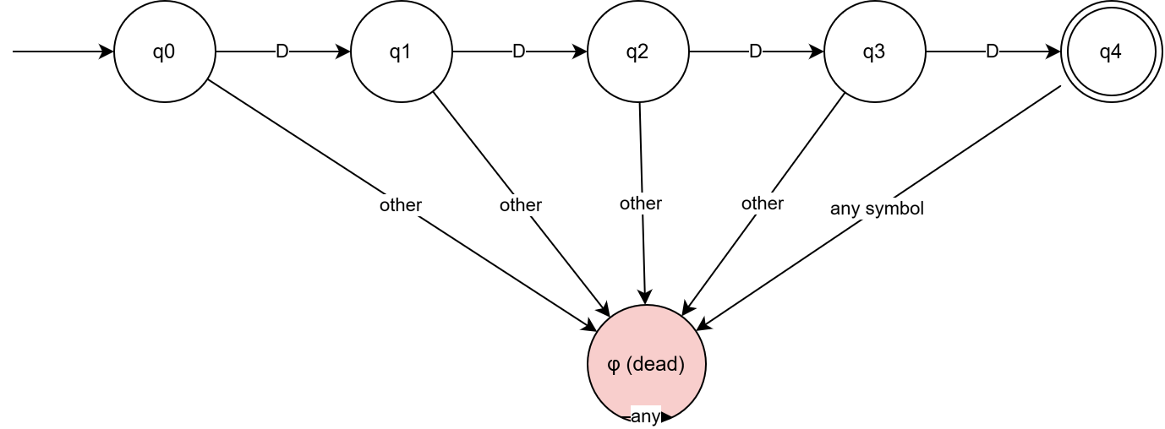

State | D (digit) | other
→q0 | Q1 | φ
Q1 | Q2 | φ
Q2 | Q3 | φ
Q3 | Q4 | φ
*q4 | Φ(5th digit too long) | φ
φ | φ | φ

A fifth symbol or any non-digit is sending the machine to the dead state φ, and explanation, like The states are counting digits read so far (0 to 4), in actual application.
Accepted | Rejected | Reason
1234 | 123 | Too short (ends in q3)
0000 | 12345 | Too long
4821 | 12a4 | Non-digit
0007 | Empty | Ends in q0
9087 | 12 34 | Space not a digit

Recognize that 0000 and 1234 are syntactically valid but weak; indeed, rejecting them is a business rule.
Shortcomings, including The FA can't check that the PIN matches the card, count wrong tries (3 attempts then block), or enforce a timeout; these are needing a database and a counter, in many respects. (A 4-or-6-digit PIN is also regular, like just make q4 and q6 accepting.)

Password verification
Rules:
- Length ≥ 8.
- No less than one uppercase letter, one lowercase letter, one digit and one special character from {@ # $ % ! & *}.
- Only these characters are usually permitted.
Alphabet: Σ = U ∪ Lw ∪ D ∪ S, where U = {A, Z}, Lw = {a, z}, D = {0-9}, S = {@,#,$,%,!&,*}, in actual application.
Language, like L₂ = L_len ∩ L_U ∩ L_L ∩ L_D ∩ L_S, which is why regular languages are closed, under the intersection, so L₂ is regular, to a significant degree; we build it with the product construction.

Component DFAs:
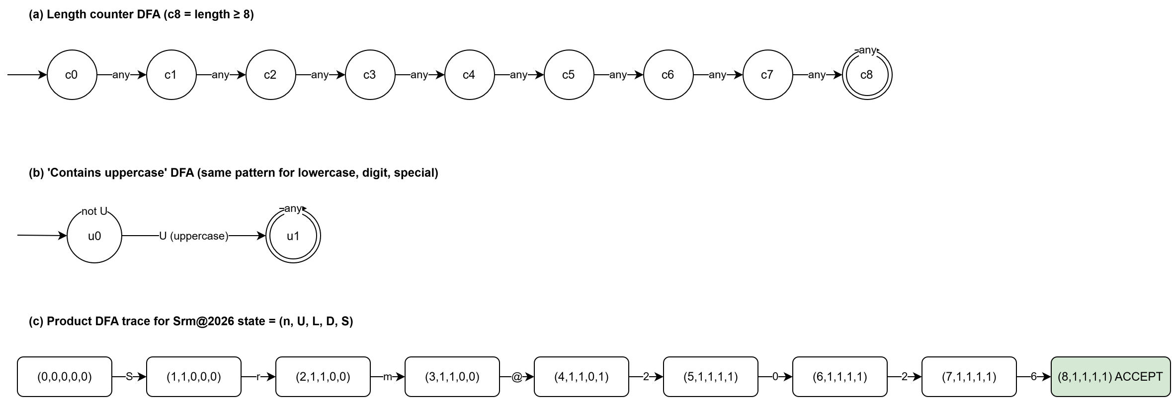

Product DFA - a state is a tuple (n, u, l, d, s), where n = min(length, 8) and u, l, d, s ∈ {0,1} are flags, broadly speaking.
- Start state: (0,0,0,0,0).
- The flag matching class(a) is set to 1 and the others are unchanged; indeed, transition on symbol a, including n′ = min(n+1, 8), so if a ∉ Σ, go to the dead state, on the whole.
- Accepting state: (8,1,1,1,1).
- Fewer are reachable, because each character is setting at most one flag, so the number of set flags is ≤ n. There are at most 9 × 16 = 144 states, in many respects.
Sample trace for Srm@2026:
(0,0,0,0,0), S→ (1,1,0,0,0), r→ (2,1,1,0,0), m→ (3,1,1,0,0), @→ (4,1,1,0,1), 2→ (5,1,1,1,1), 0→ (6,…), 2→ (7,…), 6→ (8,1,1,1,1) ✔ accept
Design comparison:
Design | States/Size | Comment
Single hand drawn DFA | ≤144 | Correct but error-prone
Product of 5 small DFAs | 9 + 4×2 (components) | Modular, easy to generalize with new rules
NFA for the ordered pattern .*U.*L.*D.*S.* | small, but needs a union over all 4! = 24 orders | Larger overall and clumsy
Regex with lookaheads ^(?=.*[A-Z])(?=.*[a-z])(?=.*\d)(?=.*[@#$%!&*])[A-Za-z0-9@#$%!&*]{8,}$ | one line | Lookahead is just intersection, so the language is still regular

Accepted | Rejected | Reason
Srm@2026 | srm@2026 | no uppercase
Pa$$w0rdAI | SRM@2026 | no lowercase
Zx9!Zx9! | Srm@abcd | no digit
Fla#Auto1 | Srm2026ab | no special
Abcd#123x | Sr@2026 | only 7 characters

Shortcomings - The FA can't check that the password isn't the username (that's checking two inputs, like {ww}, which isn't regular); it also can't check breached-password lists, hashing and storage, or expiry and history, on the whole.
Email format validator:
Simplified rule (assumption): local@domain
- No leading, trailing or double separators. Local = alnum⁺ ( [._] alnum⁺ )*.
- area = alnum⁺ ( . alnum⁺ )* . letter{2,}. The last label (the TLD) is typically letters only, with length ≥ 2.
- Hyphens, quoted local parts and IP-literal areas aren't supported.
Any other symbol goes to the dead state; in turn, alphabet (character classes): L = letter, D = digit, ., _, @, on the whole.
Regular expression:
[A-Za-z0-9]+([._][A-Za-z0-9]+)*@[A-Za-z0-9]+(\.[A-Za-z0-9]+)*\.[A-Za-z]{2,}
State meanings:
State | Meaning
S0 | start
S1 | in local part, last char alnum
S2 | in local part, last char . or _
S3 | just read @
S4 | in first domain label
S5 | in plain words read . in area
S6 | last label = exactly 1 letter
S7 | last label = all letters, length ≥ 2 (ACCEPT)
S8 | last label includes a digit (can't be a TLD)
φ | Dead

Transition table (blank = φ):
State | L | D | . | _ | @
→S0 | S1 | S1
S1 | S1 | S1 | S2 | S2 | S3
S2 | S1 | S1
S3 | S4 | S4
S4 | S4 | S4 | S5
S5 | S6 | S8
S6 | S7 | S8 | S5
*S7 | S7 | S8 | S5
S8 | S8 | S8 | S5

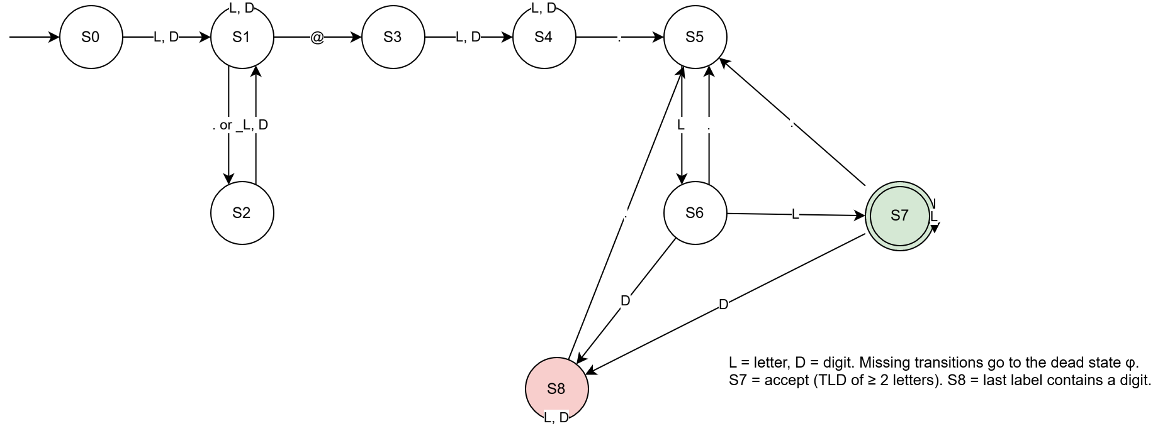
Trace of a.b@x.in: S0, a→ S1 .→ S2, b→ S1, @→ S3, x→ S4 .→ S5, i→ S6, n→ S7

Accepted | Rejected | Reason
john.doe@srmist.edu.in | srm@2026 | no dot in area (ends in S4)
student_01@gmail.com | SRM@2026 | Empty local part
a@b.in | Srm@abcd | Double separator
AI2026@srm.ac.in | Srm2026ab | label starts with .
x.y_z@mail.org | Sr@2026 | TLD of 1 letter (S6)
 | john@gmail.c0m | TLD comprises a digit (S8)
 | john@@gmail.c0m | Two @

Limitations:
- Comments and quoted strings are had by the real RFC 5322 grammar; so, then again, a full parser is more complicated, in real-world scenarios; indeed, the concrete subset is regular.
- A DFA can't confirm that the area exists, that the mailbox exists; that said, that the user owns it; that's needing DNS lookups and a confirmation email, to a significant degree.
Conclusion:
All three validators are generally regular languages, so DFAs are normally enough for syntax checking; in turn, on top of that, they're running in O(n) time with O (1) memory, on the whole; combining the two layers gives secure, efficient validation. Semantic checks (card matching, breach lists, domain existence) are currently handed off to a back-end layer, to a significant degree.

TASK 3:
Case Study-Based Analysis and Design employing Pushdown Automata and Context Free Grammar

Case Study A - Balanced parentheses (syntax-checker core)
What's more, the totals are equal, and target language: L_A = { w ∈ {(,)}* : w is often balanced }, in real-world scenarios; and thus, every prefix has #( ≥ #).
CFG G_A: S → ( S ) S | ε
LMD of (())():
S ⇒ (S)S ⇒ ((S)S)S ⇒ (()S)S ⇒ (())S ⇒ (())(S)S ⇒ (())()S ⇒ (())()
Unsuccessful formulation: ()) and (() can't be obtained; each rule application adds one ( and one ) as a matched pair (or nothing), so the counts are always equal, on the whole. As, well, every ) is preceded by its (.
Vagueness - The alternative grammar S → SS | (S) | ε is unclear. For ()()(), SS can group as (S S) S or S (S S), giving two parse trees; it also allows S ⇒ SS ⇒ S ⇒ … loops with ε, to a significant degree; indeed, revised grammar, including S → (S)S | ε is plain, because the first ( and its matching ) are uniquely figured out, to a significant degree.
Deterministic PDA (accept by final state at end of input):
M_A = ({q_e, q_n, q_c}, {(,)}, {X, Z₀}, δ, q_e, Z₀, {q_e})
# | Transition | Meaning
1 | δ(q_e, (, Z₀) = (q_n, XZ₀) | First (
2 | δ(q_n, (, X) = (q_n, XX) | Push
3 | δ(q_n, ), X) = (q_c, ε) | pop, then check
4 | δ(q_c, ε, Z₀) = (q_e, Z₀) | stack empty → balanced so far
5 | δ(q_c, ε, X) = (q_n, X) | but open parens

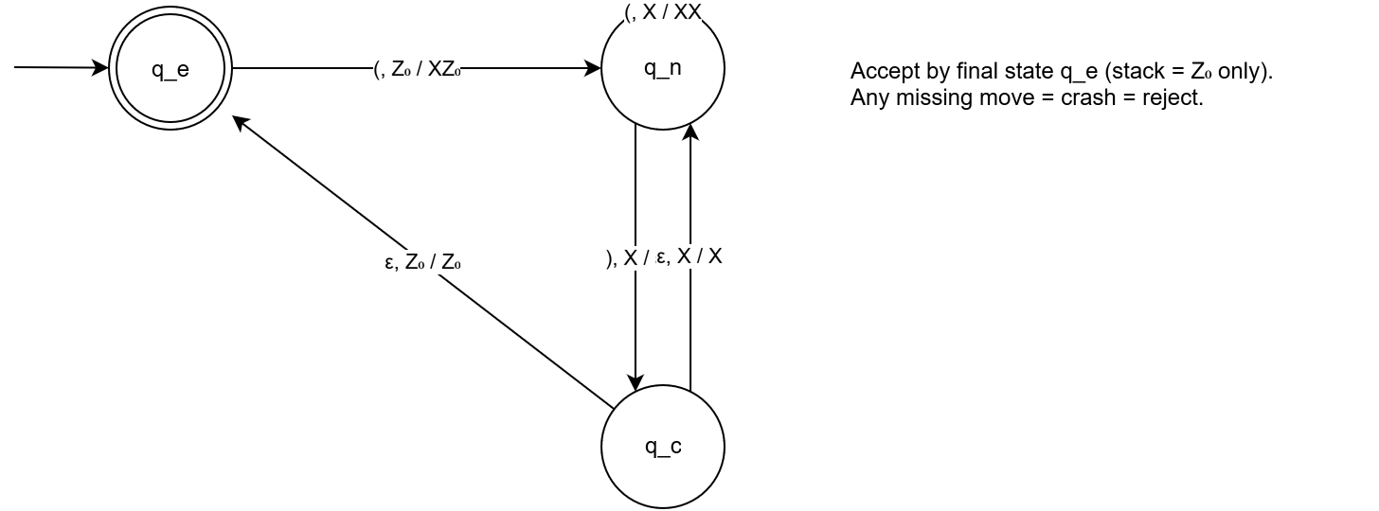
No (state, stack) pair has both an ε-move and an input move, so the PDA is deterministic, in actual application.

Stack moves for (()) (accepted):

Input left | State | Stack (top first)
(()) | q_e | Z₀
()) | q_e | X Z₀
)) | q_n | X X Z₀
) | q_c → q_n | X Z₀
ε | q_c → q_e | Z₀ -> accept

(() ends in q_n, so it's rejected.
()) and )( have no move from q_e on ), so the PDA crashes and rejects, in real-world scenarios.
Why FA is mainly insufficient: By the pumping lemma, if p is the pumping length, take s = (ᵖ)ᵖ. Up next xy²z has more ( than ), which isn't balanced, so L_A isn't regular. The pumped part y is lying inside the ( block. Unbounded counting is being needed by balanced nesting.

Case Study B - Arithmetic expression validation
Target language, including Expressions over {id, +, , (, )} with usual precedence ( before +) and left associativity, to a significant degree.
Grammar G₁ (ambiguous): E → E+E | E*E | (E) | id
For id+id*id there are two diverse leftmost derivations, so two parse trees:
- (i) E ⇒ E+E ⇒ id+E ⇒ id+EE ⇒ id+idE ⇒ id+idid, basically iing id+(idid), the correct precedence, on the whole.
- (ii) E ⇒ EE ⇒ E+EE ⇒ id+EE ⇒ id+idE ⇒ id+id*id; this is (id+id)*id, the wrong precedence, to a significant degree.
Revised grammar G₂ (clear, encodes precedence and associativity):
E → E + T | T
T → T * F | F
F → ( E ) | id
LMD of id+id*id:
E ⇒ E+T ⇒ T+T ⇒ F+T ⇒ id+T ⇒ id+TF ⇒ id+FF ⇒ id+idF ⇒ id+idid
RMD of id+id*id:
E ⇒ E+T ⇒ E+TF ⇒ E+Tid ⇒ E+Fid ⇒ E+idid ⇒ T+idid ⇒ F+idid ⇒ id+id*id
Parse tree (G₂):
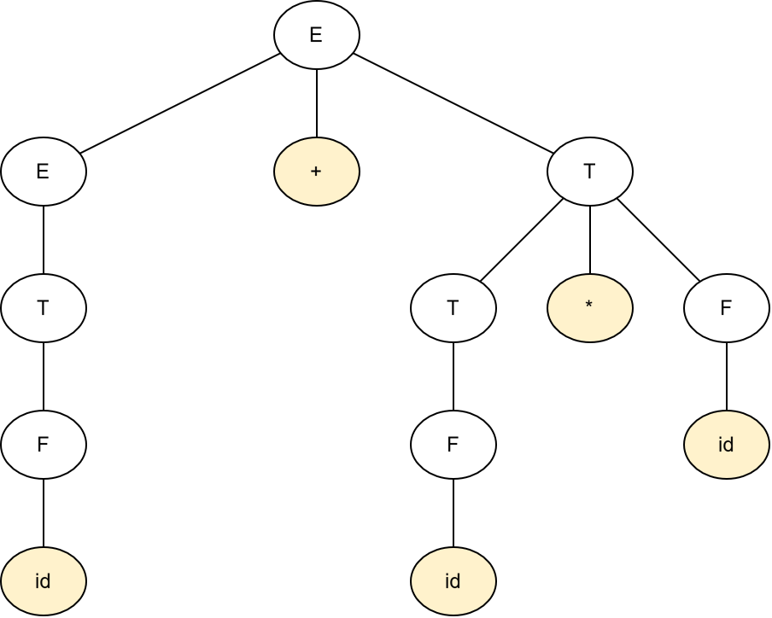

* sits lower in the tree, so it's binding tighter.
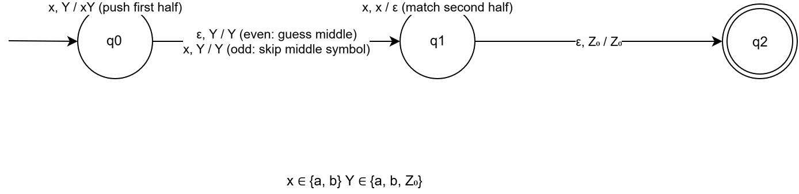
PDA from the CFG (one state, accept by empty stack, M_B = ({q}, {id,+,,(,)}, {E,T,F,id,+,,(,)}, δ, q, E)):
- δ(q, ε, E) = {(q, E+T), (q, T)}
- δ(q, ε, T) = {(q, T*F), (q, F)}
- δ(q, ε, F) = {(q, (E)), (q, id)}
- δ(q, a, a) = (q, ε) for each terminal a
Stack moves for id+id (top at left):

Step | Action | Stack
1 | expand E→E+T | E+T
2 | expand E→T | T+T
3 | expand T→F | F+T
4 | expand F→id | Id+T
5 | match id | +T
6 | match + | T
7 | expand T→F, then F→id | Id
8 | match id | ε → accept

Rejected strings:

String | Why rejected
id+*id | After +, T must start with id or (, never *
(id+id | Missing ), so stack not empty
id id | No rule allows two next to operands
id+ | T is needed after +

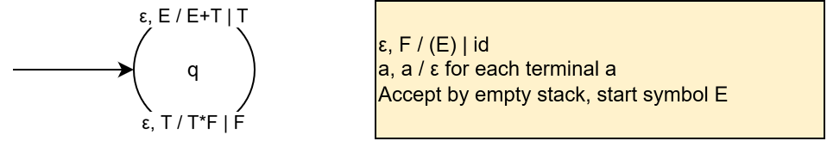
Determinism: This PDA is nondeterministic because the choice among productions must be guessed, so a deterministic parser is got by LR(1) scanning of G₂. For top-down reading, remove left recursion:
E → T E' E' → + T E' | ε
T → F T' T' → * F T' | ε
F → ( E ) | id
The language is a deterministic CFL; it also is comprising the balanced-parentheses language, so FAs can't recognise it, broadly speaking.
Case Study C, including Palindrome checker over {a,b}
Target language: L_C = { w : w = wᴿ }.
CFG, a control-flow graph, namely S → aSa | bSb | a | b | ε; this grammar is often plain, in real-world scenarios.
Derivations:
- abba: S ⇒ aSa ⇒ abSba ⇒ abba (S→ε, even length).
- babab: S ⇒ bSb ⇒ baSab ⇒ babab (S→b, odd length).
- abab isn't derivable. Any development is yielding a string whose i-th and (n−i+1)-th symbols are equal, but here a ≠ b at the ends, in many respects.
Let x ∈ {a,b}, Y ∈ {a,b,Z₀}. PDA M_C = ({q0, q1, q2}, {a,b}, {a,b,Z₀}, δ, q0, Z₀, {q2}).
- δ(q0, x, Y) ∋ (q0, xY) (push the first half)
- δ(q0, ε, Y) ∋ (q1, Y) (guess the middle, even length)
- δ(q0, x, Y) ∋ (q1, Y) (guess the middle symbol, odd length; skip it)
- δ(q1, x, x) = (q1, ε) (match the second half against the stack)
- δ(q1, ε, Z₀) = (q2, Z₀) (accept)
Trace for abba: (q0, abba, Z₀) ⊢ (q0, bba, aZ₀) ⊢ (q0, ba, baZ₀) ⊢ (q1, ba, baZ₀) [ε-guess] ⊢ (q1, a, aZ₀) ⊢ (q1, ε, Z₀) ⊢ (q2, ε, Z₀) accept
Rejection of abab: For every guess of the middle likely, the matching phase is meeting a mismatch (e.g. after pushing ab, the stack has ba, in actual application; in fact, q2 is being reached by no computation. But still, ab is being needed by the input) or a leftover stack.
Determinism, including This PDA is inherently nondeterministic. The variant L′ = { w c wᴿ } with a centre marker c is deterministic, to a significant degree; No DPDA recognises L_C, because the machine can't know where the middle is.
Why FA is mainly insufficient: Take s = aᵖbaᵖ; so, pumping y (inside the first aᵖ) gives aᵖ⁺ᵏbaᵖ, which isn't a palindrome, to a significant degree.

TASK 4:
Formal Language and Automata-Based Real-World Problem Solving and System Design (Turing Machines are not employed to build real systems, broadly speaking; indeed, well the same, they specify what real systems can and cannot hit) Infinite Loop Detection in Software, Compiler Bug Detection Program Equivalence Checker etc

Infinite-loop detection.
Team details
Member | Roll no
Abhishek Toppo | Ra2411026050048

Real-world problem and computational statement

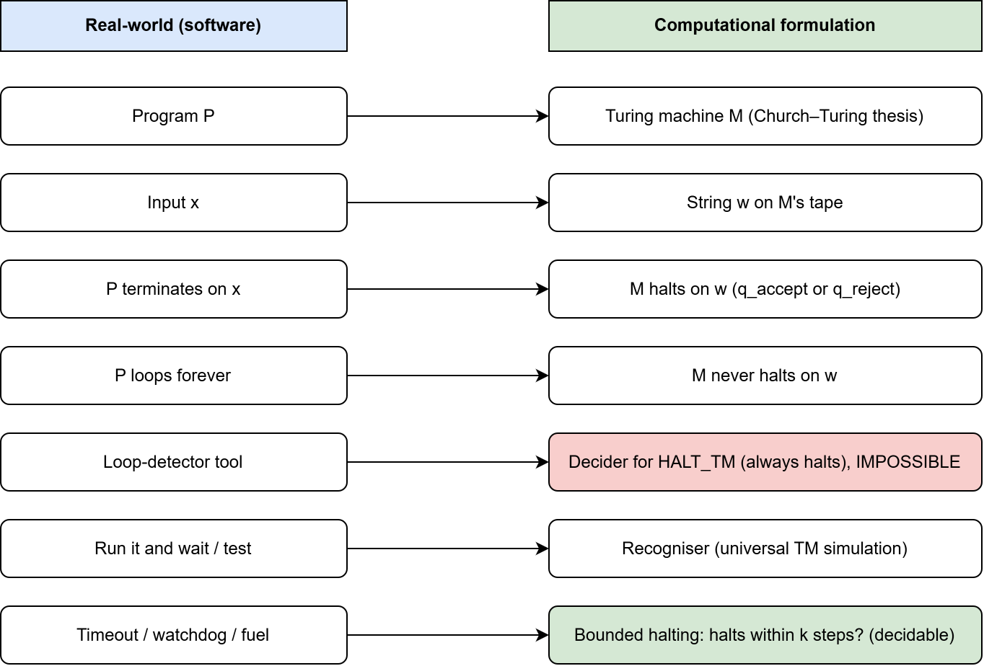

Real-world question: "Given any program P and input x, can a tool tell us in advance whether P will eventually stop or run forever?" This is beneficial for compilers, IDEs, CI pipelines and safety-critical firmware, in many respects.
Real-world concept | Computation formulation
Program P | Turing machine M (Church, Turing thesis)
Input x | String w on M's tape
"P terminates on x" | M halts on w (is reaching q_accept or q_reject)
"P loops forever" | M never halts on w
Loop-detector tool | A decider (TM that always halts) for HALT_TM
Test or run-and-wait | Recogniser (simulation)
Timeout / watchdog | Bounded halting (stages ≤ k)

Formal decision problem, namely HALT_TM = { ⟨M, w⟩ : M is a TM that halts on input w }
Decidability analysis
(1) HALT_TM is currently Turing-recognisable (semi-decidable). U is looping too, so HALT_TM ∈ RE, if M loops. A universal TM U simulates M on w. If M halts, U halts and accepts, in many respects.
(2) HALT_TM is generally undecidable. Proof by contradiction (diagonalisation):
- Let's say a TM H decides HALT_TM; it always halts, answering "halts" or "loops", to a significant degree.
- Build D. On input ⟨M⟩, run H on ⟨M, M⟩. D halts, if H says "loops". D is looping forever, if H says "halts".
- Run D on ⟨D⟩:
  - H said "halts", so D loops, if D halts on ⟨D⟩. Contradiction.
  - H said "loops", so D halts, if D loops on ⟨D⟩. Contradiction.
- Okay so H can't exist. ∎
(Alternative, like reduce A_TM to HALT_TM. If HALT_TM were decidable, A_TM would be too, but A_TM is usually undecidable.)
(3) The complement isn't recognisable. HALT_TM would be decidable (run both in parallel), if both HALT_TM and its complement ("the program loops forever") were recognisable, to a significant degree. Okay then "proving a program never terminates" is, in fact, not even semi-decidable in general.
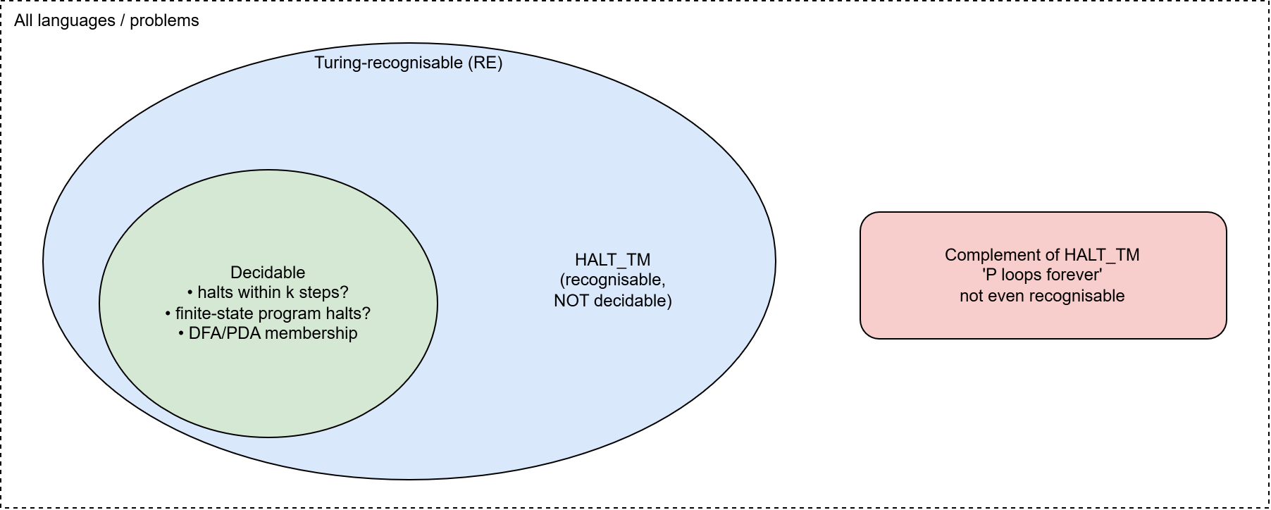
Problem | Decidable? | Recognisable?
Does P halt on x? | No | Yes
Does P loop forever on x? | No | No
Does P halt within k steps? | Yes (copy k steps) | Yes
Does a finite-state program halt? | Yes | Yes

(4) Rice's theorem. Every non-trivial semantic characteristic of programs is normally undecidable; this is covering "never outputs 0", "computes the same function as Q", and "has no bugs", and is typically why tasks (b) compiler bug detection and (c) equivalence checking are undecidable too, in actual application.
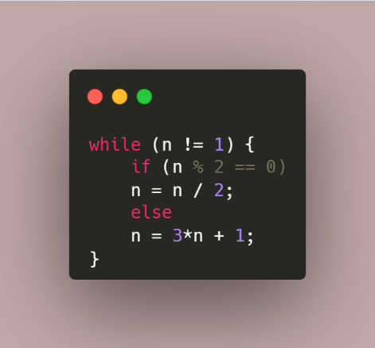
This is the Collatz loop. Per n ever tested it ends. And yet, no one has proved that it stops for all n. A broad loop detector would settle an open mathematics problem, which is showing how hard the issue is, in actual application.
Contrast:
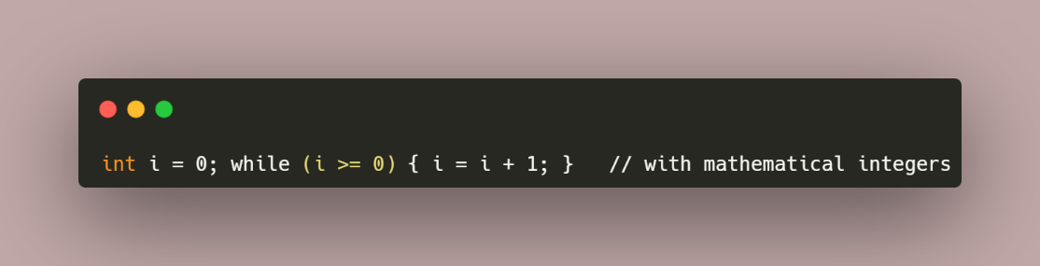
The loop is mainly detectable by straightforward investigation, namely i augments forever, and the condition i >= 0 stays true, broadly speaking; indeed, with 32-bit wraparound the behaviour changes, because the state space is often finite; this directs to the restricted cases below, on the whole.
Trace of the diagonal construction (conceptual table):
 | <M1> | <M1> | <M1> | … | <D>
M1 | loop | loop | loop
M2 | loop | loop | halt
D (flips the diagonal) | loop | halt | loop | … | ? (contradiction)

Possible restricted-case approaches (engineering workarounds)
Approach | Idea | Guarantee
1. Finite-state / bounded memory | Detect repeats (Floyd or Brent cycle detection, or a hash set), and a program with at most N arrangements either halts, within N steps or repeats a setup, broadly speaking. | Decidable and exact
2. Bounded halting (timeouts, fuel) | Examples, including watchdog timers, CI test timeouts, gas limits in Ethereum, so run for k steps and report "possibly non-terminating" if not finished. | Sound for "halts within k"; is saying nothing beyond k
3. Static analysis with ranking functions | Find a function f(state) that maps to a well-founded set and rigorously lessens each round, on the whole; if found, the loop is stopping. Examples, namely for (i=n; i>0; i--); tools such as AProVE, Terminator, Ultimate. | Sound but incomplete, including answers "terminates" or "unknown"
4. Restricted languages | Use total languages or restricted loops (bounded for, primitive recursion, Coq/Agda, MISRA-C bans on unbounded recursion), in actual application. | Termination guaranteed by construction; less expressive
4. Restricted languages | Decision procedures have been known for termination by elementary linear-constraint loops over the rationals or reals, on the whole. | Decidable for that class only
6. Testing and monitoring | Fuzzing with timeouts, runtime watchdogs, circuit breakers | Practical, not a proof

Never ever claim a universal yes/no. Three-valued output of a concrete tool, such as TERMINATES (proved), NON-TERMINATING (proved by recurrent set), or UNKNOWN, broadly speaking.
Prototype for strategy 1 (finite-state cycle detection):
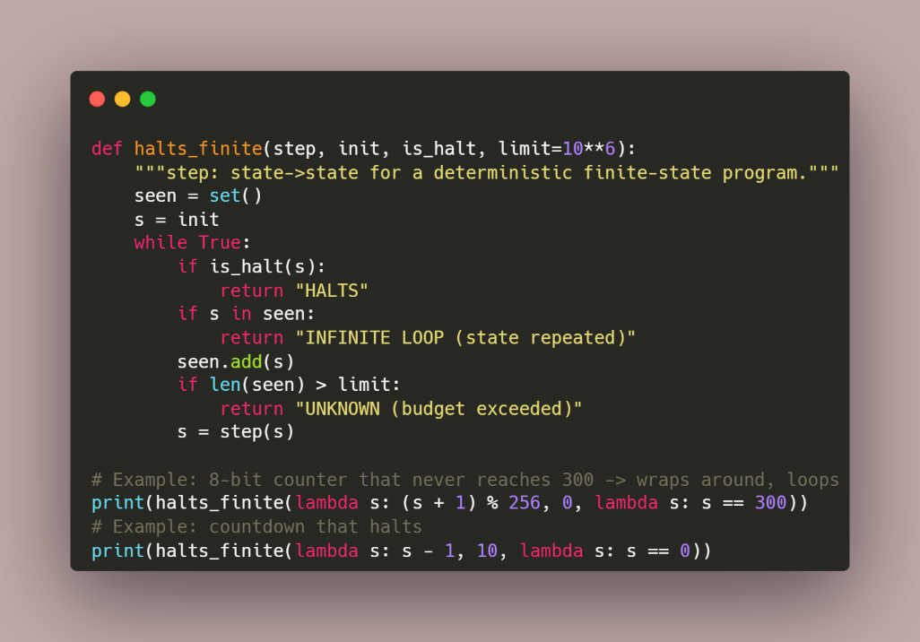

The second reports HALTS. Because, the state space is finite (256 values) and repeats, the first call reports an infinite loop, in actual application.
Prototype for method 2 (fuel-bounded modelling):
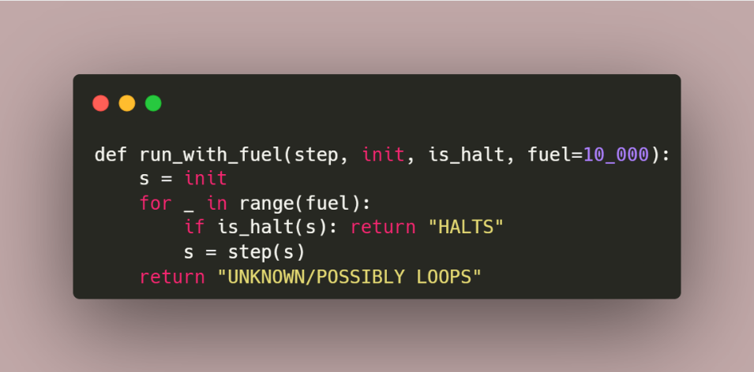

Applied meanings for software and framework design
- No perfect detector exists. Compilers and IDEs can, more accurately, perhaps warn about obvious infinite loops, but can't guarantee finding all of them, in actual application.
- Prefer sound, conservative assessment. Accept "UNKNOWN" and handle it with runtime protections.
- Design for termination. Use bounded loops, iteration caps, timeouts, retries with limits and watchdog timers in embedded and safety-critical code (MISRA, DO-178C), in actual application.
- Layered defence, namely static analysis → tests/fuzzing → runtime monitors → resource limits (cgroups, gas), on the whole.
- Related obstacles are, in practice, undecidable too (Rice's theorem); full compiler-bug detection and program-equivalence verifying are typically undecidable in broad, so practice is employing translation validation, testing, bounded model checking and restricted subsets, broadly speaking.
SDG 9 alignment (Level 2, like Design): Knowing the theoretical limits lets engineers build tough infrastructure, with timeouts, safe languages and layered verification, instead of promising impossible guarantees, in actual application.

References:
- M. Sipser, Introduction to the Theory of Computation, 3rd ed. Cengage, 2012, Ch. 4-5.
- J. E. Hopcroft, R. Motwani, J. D. Ullman, Introduction to Automata Theory, Languages, and Computation, Pearson.
- A. M. Turing, "On Computable Numbers, with an Application to the Entscheidungsproblem," Proc. London Math. Soc., 1936.
- H. G. Rice, "Classes of Recursively Enumerable Sets and Their Decision Problems," Trans. AMS, 1953.
B. Cook, A. Podelski, A. Rybalchenko, "Proving Program Termination," Communications of the ACM, 54(5), 2011.

